**14 Sept 2018** **The Weekly Bulletin of Rotary Club of Kathmandu Mid-Town** **bc-2.9/018**

|  |
| --- |
| C:\Users\Public\Documents\RIP T1819_EN.png |

District: 3292 Web:www.rotarymidtown.org.np Club Id: 26776

**SEPTEMBER IS THE BASIC EDUCATION AND LITERACY MONTH**

**Basic education and literacy is one of Rotary’s six areas of focus.**

On Girls’ Education:

“It’s plain on the page and proved on the ground that funding girls’ education isn’t charity but investment, and the returns are transformational. When you invest in girls and women, they rise and lift their families, communities, economies, and countries. They rise and they lead.”

“Give them as much schooling as boys, and things really start changing. Closing the gender gap in education could generate $ 112 billion to $ 152 billion a year for developing countries in South Asia.”

PRIP Kalyan Banerjee

On improving government schools:

Introduce school vouchers. Under the voucher system the government instead of giving money to government schools, gives vouchers to parents, who then choose the best school for their children, and submit the voucher there. The school then gives the voucher to the government and gets the money to pay the teachers. This changes the incentives for government school teachers. They have to perform now, and deliver quality education, or parents will take their kids elsewhere. Competition brings accountability. This also empowers parents with choice; they can decide what is best for their children.   
“The state, instead of funding schools, as is done now, funds schooling.” PRIP Kalyan Banerjee

Source: Rotary News, March 2018

Club Meeting # 1456 : 7 Sep 018

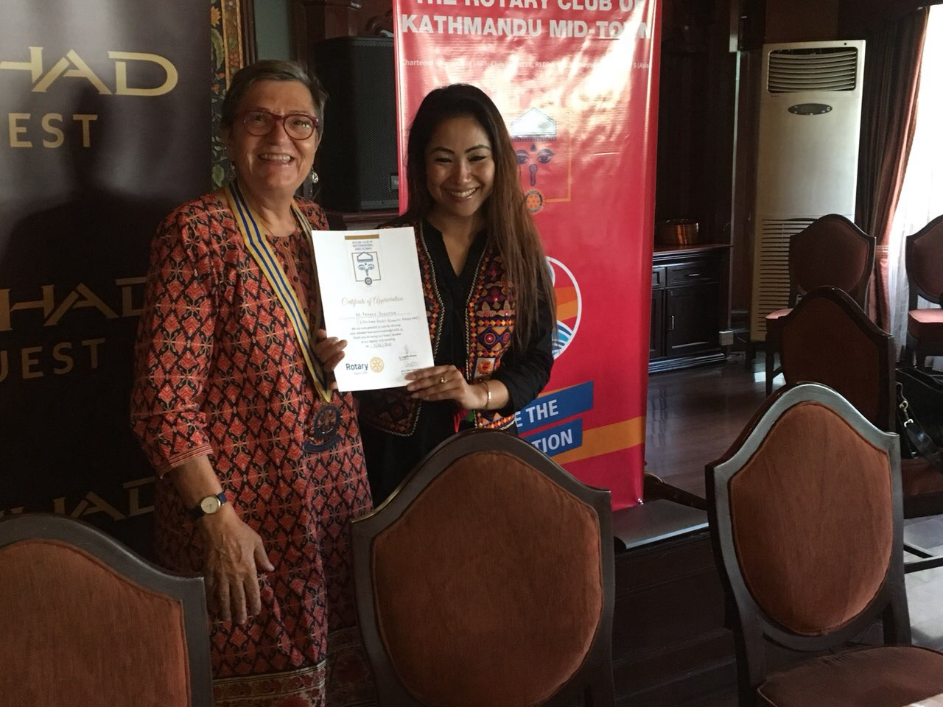

Guest speaker Pawana Shrestha receiving

a certificate of appreciation from Club President Jo

Guest speaker Pawana Shrestha talked about

marketing, branding, earning points in Etihad Airways,

how they can be used, how they are different from

other airlines, market segmentation, humatarian fares,

success of strategic marketing etc.

She entertained the audience in her presentation by

asking questions, inviting participation etc.

After her presentation, and Q/A session, she

started a small quiz, of course with permission of

President Jo, to give away Etihad Airways gifts she

brought along for giving to participants. She threw a

question to the floor and whoever gave quick a correct

answer got a gift. She had 4 packets of gift, so she

framed 4 simple questions pertaining to Etihad Airways.

The quiz winners receiving Etihad gift:

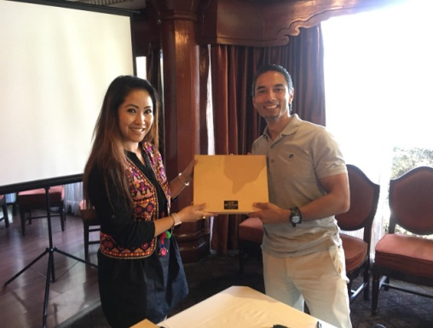 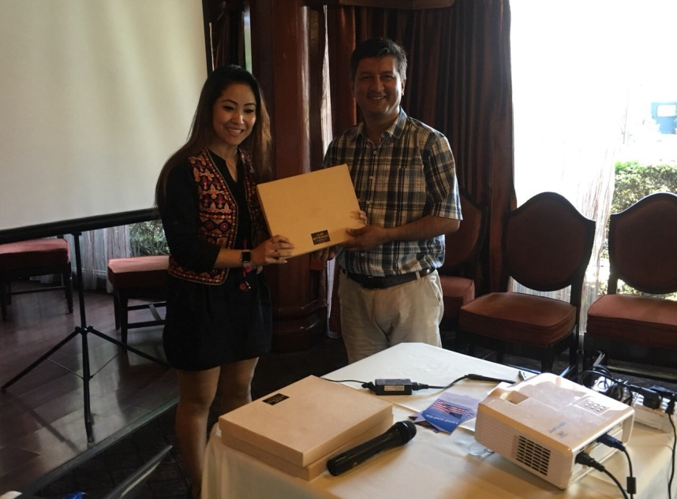 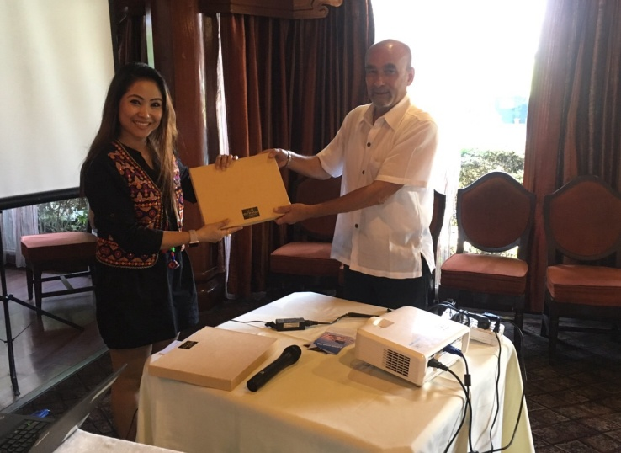 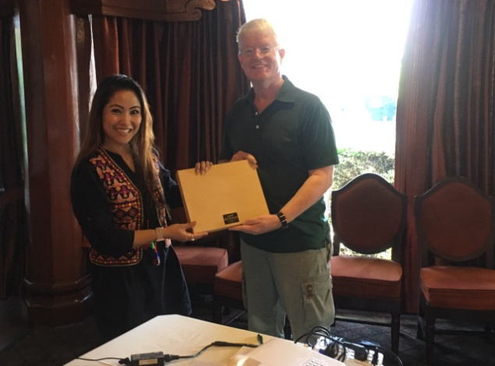

Rabi Pramod Govinda Dale

# Weekly Meeting/Program Schedule:

|  |  |  |
| --- | --- | --- |
| Date | Program/ Speaker | Topic of Presentation |
| 14 September | PP Mani D Joshi | Rotary in Nepal |

Friday Meeting: 14 Sept



PP Mani D Joshi will be talking on overall Rotary activities in Nepal.

On many occasions he is a source of information on Rotary.

Members may benefit by actively participating in the talk.

Inhouse speaker

**Board of Directors’ meeting:**

The Club’s third Board meeting was held on Tuesday 11 Sept

At Hotel Manaslu, Lazimpat.

Program host: Rtn Shyam R Thapalia

**Visiting Navakiran Orphanage**: On Saturday 15 September 2018

Good news: District Governor and District Secretary will be joining us in the program.

We will be handing over two cheques to the orphanage – one for Rs 500,000 to pay for roofing and another for Rs 50,000 to pay for purchase of 20 mattresses. The cheques will be handed over by the visiting DG. Besides witnessing the program of cheque handover, the visitors will have an opportunity of fellowship with the beneficiaries on the one hand and also of having first-hand observation of the implemented project on the other.

Mid-Towners who have not signed the sign-up sheet will hopefully reconsider and go for sign-up sheet.

Fellow Rtn Paras Rana is coordinating the program. Please contact him for any details.

**Walking Circle:**

Saturday morning, Rotarians in a group go on walks if other factors such as ‘no rain’, or ‘having *fursad*’ remain suitable/favourable!

This Saturday a group went on walking in north Kathmandu hills beyond Budhanilkantha.

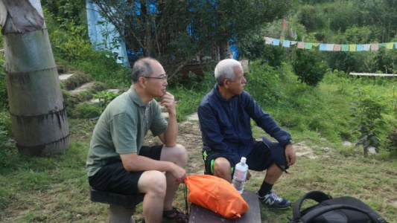 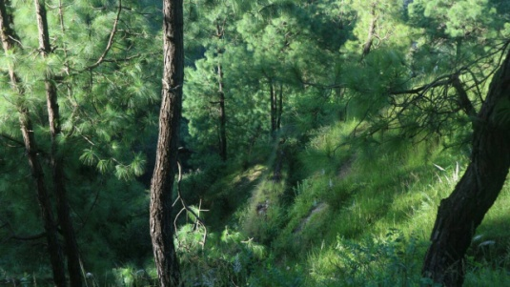 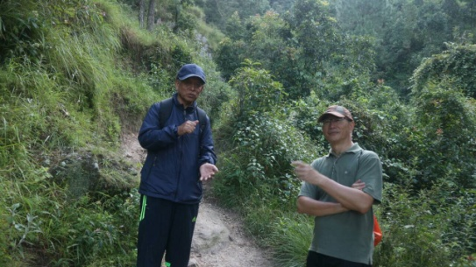

Waiting for other walkers? Where have the walkers gone? Bet, we are on right track!

**Tourism Promotion:**

Nepal participated in the 5th Sichuan International Travel Expo (SCITE) held in Leshan, China from September 6 to 9. “Nepal has received unprecedented religious and tourism mileage as Birthplace of Lord Buddha during the expo,” reads a statement issued by Nepal Tourism Board (NTB).

A memorandum of understanding was signed between Leshan, the home of the biggest Buddha statue in the world, and Lumbini, Tansen and Ramgram for promotion of Buddhist tourism.

“A special ceremony was held to hand over the holy soil from Lumbini to Leshan Buddha Museum where it was consecrated.”

The Nepal Week, a week-long exhibition and sale of Nepali handicrafts with over 50 stalls, culinary delights, photo exhibition, live pottery and cultural dances were held for the visitors. Holding the Nepal Week is the starting campaign for promotion of ‘Visit Nepal 2020’ in China.

**A THOUGHT FOR TODAY:**

[Knowing a great deal is not the same as being smart;](http://thinkexist.com/quotation/knowing_a_great_deal_is_not_the_same_as_being/198021.html)

[Intelligence is not information alone but also judgment,](http://thinkexist.com/quotation/knowing_a_great_deal_is_not_the_same_as_being/198021.html)

[the manner in which information is collected and used](http://thinkexist.com/quotation/knowing_a_great_deal_is_not_the_same_as_being/198021.html)[.](http://www.brainyquote.com/quotes/quotes/b/baruchspin101666.html" \o "view quote)

***Dr. Carl Sagan***

**Committee Chairs’ Column:** *(This column is for use by chairpersons of 5 permanent committees: Club Administration, Membership, Public Relations, Service Projects, and the Rotary Foundation)*

**Members’ Corner:** *(This column is for Club members to express anything they would like in matter of Club activities, Club administration, Club issues or on Breakfast Chatter, or on anything else that would be of interest to fellow members.)*

**Do you know?**

Dermatoglyphics: the study of fingerprints, is one of the longest English words that doesn’t repeat any letters.

**Photo courtesy:**

All photos from Rtn Shyam R Thapalia. Many thanks !

On Lighter Side:

One day in a small town during really stormy weather, the town begins to flood. Everyone rushes to lifeboats and begins to flee. But in a church a priest sits on the altar and does not move. A man runs up to him. Man: "Father, come quickly, we have a lifeboat ready for you."

Priest: No, there is no need for me to flee for the Lord will provide and he will save me".   
A few hours later water level rises up to the altar where the priest is standing. A lifeboat zooms through the door with a few men in it. One man calls to the priest, "Father come quickly."

Priest: "No, Lord will provide and he will save me."

So the lifeboat zooms off.

A few hours later water level rises up to the crucifix on which the priest is hanging on.

Another lifeboat zooms in. A man in the boat loudly calls, Father, the town is flooding, you must come with us to safety.

Priest: No, Lord will send me safety boat. He will save me.

A few hours later water level rose up to the roof and the priest drowned.

Later in Heaven the priest met God and he complained: "Lord, why didn't you save me? I had so much faith on you.

God- What are you talking about! I sent 3 lifeboats to rescue you!!

.

**On Rotary:**

Make use of the *Membership Leads* tool at Rotary.org which helps people who are interested in joining Rotary connect with a club that's right for them.

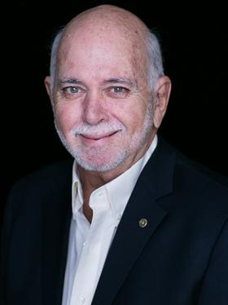

And let's ensure that every member has a reason to stay. By building strong clubs that engage in meaningful projects and have fun along the way, we provide value to our club members that they cannot find anywhere else.

**RI President Barry Rassin**

Please send information on club activities, progress reviews on service projects, relevant photos etc to:

BC Editor: RR Shrestha email: rryesrr@gmail.com

## 14 Sept 2018 The Weekly Bulletin of Rotary Club of Kathmandu Mid-Town bc-2.9/018